**Air Force Institute of Technology**

**Graduate School of Engineering and Management**

**Department of Electrical and Computer Engineering**

**CSCE 532 Automata and Formal Languages**

**Winter 2019**

# Day 10 - The Church-Turing Thesis

§3.1 Turing Machines

### Definition

A **Turing machine** is a 7-tuple $(Q,Σ,Γ,δ,q_{0},q_{accept},q_{reject})$, where $Q,Σ,Γ$ are all finite sets and

1. $Q$ is the set of states,
2. $Σ$ is the input alphabet not containing the blank symbol ␣,
3. $Γ$ is the tape alphabet, where ␣ $∈Γ$ and $Σ⊆Γ$,
4. $δ:Q×Γ→Q×Γ×\{L,R\}$ is the transition function,
5. $q_{0}∈Q$ is the start state,
6. $q_{accept}∈Q$ is the accept state, and
7. $q_{reject}∈Q$ is the reject state, where $q_{reject}≠q_{accept}$.

### Terminology and Notation

A **configuration** of a TM specifies its current state, tape contents, and head location. Specifically, for state $q∈Q$ and strings $u,v∈Γ^{*}$, the configuration $uqv$ specifies that the machine is in state $q$, that the tape contains $uv$, and that the head is positioned over the first symbol of $v$.

The **start configuration** of a TM with input $w$ is $q_{0}w$.

Any configuration involving the state $q_{accept}$ ($q_{reject}$) is an **accepting (rejecting) configuration**.

A **halting configuration** is one that is accepting or rejecting.

A configuration $C_{1}$**yields** configuration $C_{2}$ if the TM can legally go from $C_{1}$ to $C_{2}$ in one step.

A TM $M$**accepts** input $w$ if a sequence of configurations $C_{1},C_{2},…,C_{k}$ exists, where

1. $C_{1}$ is the start configuration of $M$ on input $w$,
2. Each $C_{i}$ yields $C_{i+1}$, and
3. $C_{k}$ is an accepting configuration.

The collection of strings that $M$ accepts is the **language of $M$** , or the **language recognized by $M$** , denoted $L(M)$.

In general TMs can accept, reject, or loop. A TM that halts on all inputs is called a **decider**. A decider that recognizes some language is also said to **decide** it.

### Definition

Call a language **Turing-recognizable** (or **recursively enumerable**) if some TM recognizes it.

### Definition

Call a language **Turing-decidable** (or **decidable**, or **recursive**) if some TM decides it.

### Example (Sipser exercise 3.1C)

This exercise concerns the TM $M_{2}$ of Example 3.7 that decides $A=\{0^{2^{n}}|n≥0\}$, the language consisting of all strings of $0$ s whose length is a power of $2$.

$M_{2}=$“On input string $w$:

1. Sweep left to right across the tape, crossing off every other $0$.
2. If in stage 1 the tape contained a single $0$, accept.
3. If in stage 1 the tape contained more than a single $0$ and the number of $0$ s was odd, reject.
4. Return the head to the left-hand end of the tape.
5. Go to stage 1.”

The formal description of $M_{2}=(Q,Σ,Γ,δ,q_{1},q_{accept},q_{reject})$ is:

* $Q=\{q_{1},q_{2},q_{3},q_{4},q_{5},q_{accept},q_{reject}\}$,
* $Σ=\{0\}$, and
* $Γ=\{0,x,␣\}$.
* $δ$ is described by the state diagram below.[1]
* The start, accept, and reject states are $q_{1}$, $q_{accept}$, and $q_{reject}$, respectively.

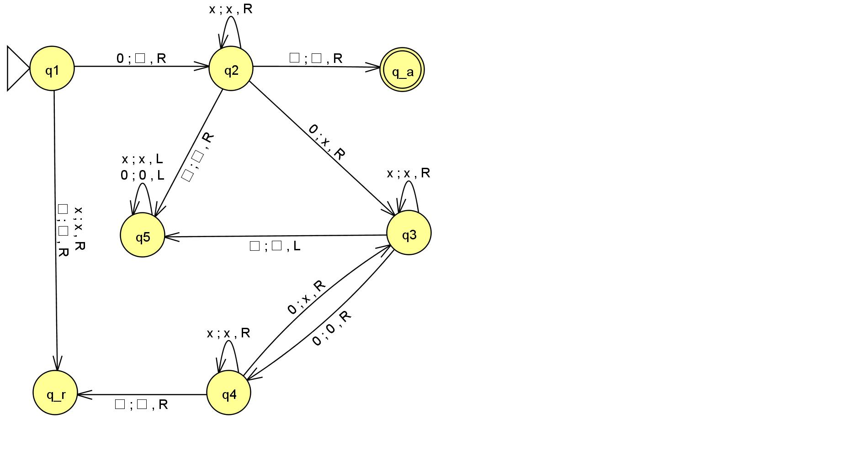

Give the sequence of configurations that $M_{2}$ enters when started on $000$.

#### Solution

$$q_{1}000 \\ ␣q_{2}00 \\ ␣xq_{3}0 \\ ␣x0q_{4}␣ \\ ␣x0␣q_{reject}␣$$

### practice (sipser Exercise 3.1d)

Give the sequence of configurations that $M_{2}$ enters when started on $0000$.

$$q_{1}0000 \\ ␣q_{2}000 \\ ␣xq_{3}00 \\ ␣x0q_{4}0 \\ ␣x0xq_{3}␣ \\ ␣x0q_{5}x␣ \\ ␣xq_{5}0x␣ \\ ␣q_{5}x0x␣ \\ q_{5}␣x0x␣ \\ ␣q_{2}x0x␣ \\ ␣xq_{2}0x␣ \\ ␣xxq_{3}x␣ \\ ␣xxxq_{3}␣ \\ ␣xxq_{5}x␣ \\ ␣xq_{5}xx␣ \\ ␣q_{5}xxx␣ \\ q_{5}␣xxx␣ \\ ␣q_{2}xxx␣ \\ ␣xq_{2}xx␣ \\ ␣xxq_{2}x␣ \\ ␣xxxq_{2}␣ \\ ␣xxx␣q_{accept}␣$$

### Practice (Sipser Exercise 3.5a)

Examine Sipser’s formal definition of a Turing machine to answer the following questions, and explain your reasoning.

1. Can a TM ever write the blank symbol ␣ on its tape?
2. Can the tape alphabet $Γ$ be the same as the input alphabet $Σ$?
3. Can a TM’s head ever be in the same location in two successive steps?
4. Can a TM contain just a single state?

#### Solution

1. Yes. The blank symbol ␣ is by definition an element of the tape alphabet $Γ$.
2. No. The blank symbol ␣ is by definition not an element of the input alphabet $Σ$.
3. No. According to Sipser’s definition, the tape head always moves left or moves right.
4. No. According to Sipser’s definition, $q_{accept}∈Q$, $q_{reject}∈Q$, and $q_{accept}≠q_{reject}$.

### practice (Sipser exercise 3.8b)

Give an implementation level description of a TM that decides the language

$$\left\{w∈{\left\{0,1\right\}}^{*} | w contains twice as many 0s as 1s\right\}.$$

#### Solution

1. In the JFLAP image, $□$ represents ␣, $q_a$ represents $q_{accept}$, and $q_r$ represents .